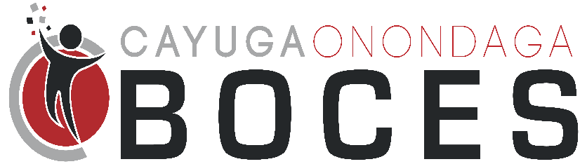
Summer 2023 STEAM Camp

AUTHORIZATION FOR EMERGENCY TREATMENT
OF MINORS IN ABSENCE OF PARENT
I give permission for my child ________________________________ DOB ________________ to receive emergency medical, dental or surgical care at the nearest medical facility, without my presence, in case of an emergency situation deemed necessary by the attending physician.
Medical Conditions: _____________________________________________________________
Allergies: ______________________________________________________________________
Other: ________________________________________________________________________
Family Physician  _____________________________ | Phone: ___________________________
Emergency contact 1:  _____________________________ | Home Phone: ___________________________  Business Phone: ___________________________  Cell Phone: ___________________________
Emergency contact 2:  ______________________________ | Home Phone: ___________________________  Business Phone: ___________________________  Cell Phone: ___________________________
I understand that every effort will be made to contact me and that this form will authorize emergency medical treatment until I arrive at the medical facility or in the event my presence being impossible. This form is valid for the duration of enrollment in the Cayuga-Onondaga BOCES 2023 Summer STEAM Camp program unless revoked by me.

Date: | Signature of Parent or Legal Guardian

