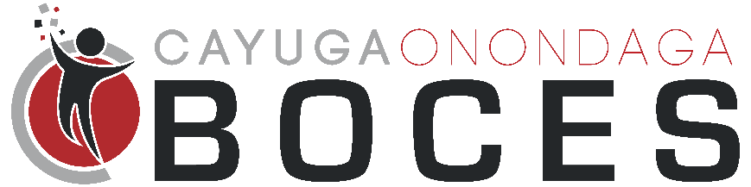
Summer 2023 STEAM Camp

July 24 – July 28, 2023
8:00 AM – 8:30 AM Student Drop Off
8:30 AM – 3:00 PM STEAM Camp
Registration form
Student Name
Address
City |  |  | Zip
Parent/Guardian
Parent/Guardian Phone
Parent/Guardian Email *Required
School District
Grade Level (as of September 1, 2023)
T-shirt Size (Please indicate youth or adult sizes.)

School Administrator Signature _______________________________
Cayuga-Onondaga BOCES campus
1879 West Genesee Street Road
Auburn, NY 13021

