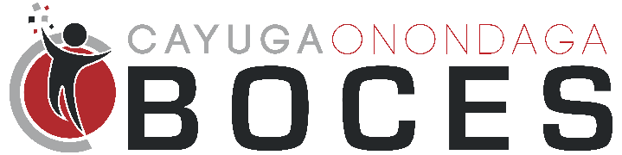

Summer 2023 STEAM Camp

Media Release

NEWSPAPER INTERVIEW, VIDEORECORDING & PHOTOGRAPH PERMISSION FORM

As parent/guardian of _____________________________________, I give permission to the Cayuga-Onondaga BOCES to interview, digitally capture video and audio and/or photograph my son/daughter while enrolled in the 2023 SUMMER STEAM CAMP. These items or files are for use in school-related publications, displays, news media articles and other instructional activities

Date: | Signature of Parent or Legal Guardian

